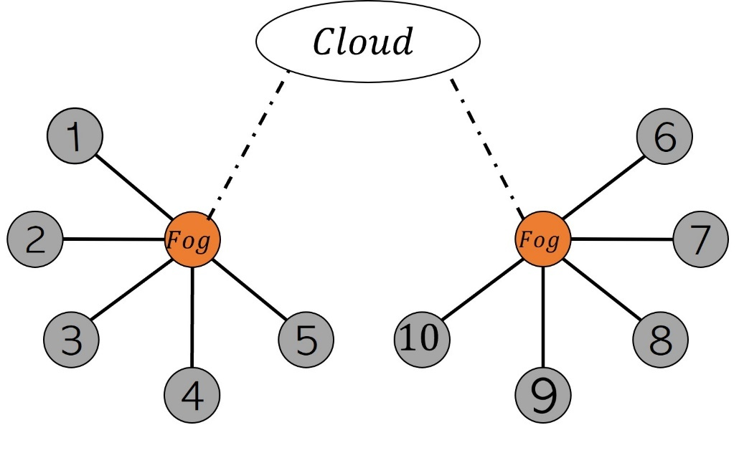

Synchronize configuration

**FD001:**

GD: Number of iterations: 3000 / 3000

GD: final norm: 0.029324850454818634

-------------------------------------

Runtime GD num_iters= 61.58211660385132

final cost with GD 439.3743409743638

final acc with 10 workers FedSVM_GD: 0.9241071428571429

SGD: Number of iterations: 3000 / 3000

SGD: final norm: 17.727065349322608

-------------------------------------

Runtime SGD num_iters= 18.95768904685974

final cost with SGD 428.03605530147206

final acc with 10 workers FedSVM_SGD: 0.9252645502645502

FSVRG: Number of iterations: 2999 / 3000

FSVRG: final norm: 2.298711312251056

-------------------------------------

Runtime FSVRG num_iters= 140.5303554534912

final cost with FSVRG 428.03605530147206

final acc with 10 workers FedSVM_FSVRG: 0.9029431216931217

**FD002:**

GD: Number of iterations: 3000 / 3000

GD: final norm: 0.05166381461244866

-------------------------------------

Runtime GD num_iters= 150.09136390686035

final cost with GD 2017.2900022631538

final acc with 10 workers FedSVM_GD: 0.7791970802919708

SGD: Number of iterations: 3000 / 3000

SGD: final norm: 33.96478802530125

-------------------------------------

Runtime SGD num_iters= 43.08852696418762

final cost with SGD 2065.3220508939057

final acc with 10 workers FedSVM_SGD: 0.789470127061368

FSVRG: Number of iterations: 2999 / 3000

FSVRG: final norm: 12.211605761606558

-------------------------------------

Runtime FSVRG num_iters= 362.3987376689911

final cost with FSVRG 2065.3220508939057

final acc with 10 workers FedSVM_FSVRG: 0.739794539064612

**FD003:**

GD: Number of iterations: 3000 / 3000

GD: final norm: 0.03051279849654387

-------------------------------------

Runtime GD num_iters= 69.03829836845398

final cost with GD 564.9196621077692

final acc with 10 workers FedSVM_GD: 0.942188679245283

SGD: Number of iterations: 3000 / 3000

SGD: final norm: 33.99593709012081

-------------------------------------

Runtime SGD num_iters= 20.478586196899414

final cost with SGD 611.1210276133922

final acc with 10 workers FedSVM_SGD: 0.9215094339622641

FSVRG: Number of iterations: 2999 / 3000

FSVRG: final norm: 3.072395654809379

-------------------------------------

Runtime FSVRG num_iters= 161.05999660491943

final cost with FSVRG 611.1210276133922

final acc with 10 workers FedSVM_FSVRG: 0.9175849056603773

**FD004:**

GD: Number of iterations: 3000 / 3000

GD: final norm: 0.02851879139321114

-------------------------------------

Runtime GD num_iters= 143.5475242137909

final cost with GD 2099.4373076555335

final acc with 10 workers FedSVM_GD: 0.7844002943340692

SGD: Number of iterations: 3000 / 3000

SGD: final norm: 27.451618304546987

-------------------------------------

Runtime SGD num_iters= 45.49013876914978

final cost with SGD 2236.308160762267

final acc with 10 workers FedSVM_SGD: 0.7170738287956832

FSVRG: Number of iterations: 2999 / 3000

FSVRG: final norm: 5.237116366918994

-------------------------------------

Runtime FSVRG num_iters= 337.4242241382599

final cost with FSVRG 2236.308160762267

final acc with 10 workers FedSVM_FSVRG: 0.8684081432425803

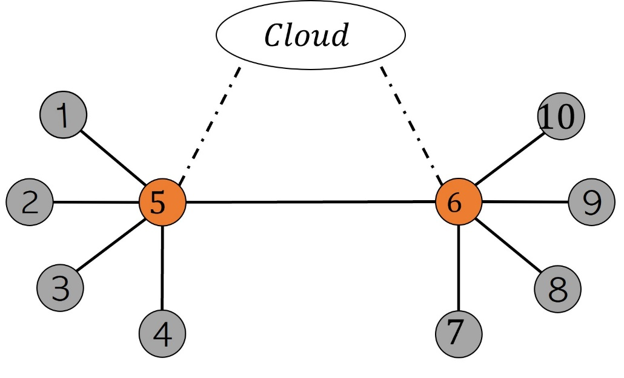

Asynchronous

**FD001:**

GD: Number of iterations: 3000 / 3000

GD: final norm: 1.112946279012654

-------------------------------------

Runtime GD num_iters= 61.84509587287903

final cost with GD 499.9978121099075

final acc on Cloud FedSVM_GD: 0.9224537037037037

SGD: Number of iterations: 3000 / 3000

SGD: final norm: 8.593597313589722

-------------------------------------

Runtime SGD num_iters= 19.819461584091187

final cost with SGD 556.2596286038398

final acc on Cloud FedSVM_SGD: 0.9045965608465608

**FD002:**

GD: Number of iterations: 3000 / 3000

GD: final norm: 0.10820903886958683

-------------------------------------

Runtime GD num_iters= 145.09288549423218

final cost with GD 2001.6942356538507

final acc on Cloud FedSVM_GD: 0.7723033252230332

SGD: Number of iterations: 3000 / 3000

SGD: final norm: 12.32529518324616

-------------------------------------

Runtime SGD num_iters= 42.53922748565674

final cost with SGD 2063.3280102792714

final acc on Cloud FedSVM_SGD: 0.2183698296836983

**FD003:**

GD: Number of iterations: 3000 / 3000

GD: final norm: 0.5236254002209448

-------------------------------------

Runtime GD num_iters= 68.64798879623413

final cost with GD 558.7551888946161

final acc on Cloud FedSVM_GD: 0.938566037735849

SGD: Number of iterations: 3000 / 3000

SGD: final norm: 9.52330804447412

-------------------------------------

Runtime SGD num_iters= 21.452486038208008

final cost with SGD 609.958051159747

final acc on Cloud FedSVM_SGD: 0.9216603773584906

**FD004:**

GD: Number of iterations: 3000 / 3000

GD: final norm: 0.20737783535574003

-------------------------------------

Runtime GD num_iters= 141.46264386177063

final cost with GD 2111.3896468415305

final acc on Cloud FedSVM_GD: 0.7712779004169733

SGD: Number of iterations: 3000 / 3000

SGD: final norm: 10.547920172399

-------------------------------------

Runtime SGD num_iters= 43.87217664718628

final cost with SGD 2901.323937245611

final acc on Cloud FedSVM_SGD: 0.8316163845965171

Table 2. performance

|  |  |  |  |  |  |
| --- | --- | --- | --- | --- | --- |
| optimize | Evaluation metric | Dataset | | | |
| FD001 | FD002 | FD003 | FD004 |
| DG | Runtime | 1 | 2 | 3 | 4 |
| Final acc | 5 | 6 | 7 | 8 |
| SGD | Runtime | 9 | 10 | 11 | 12 |
| Final acc | 13 | 14 | 15 | 16 |
| FSVRG | Runtime | 17 | 18 | 19 | 20 |
| Final acc | 21 | 22 | 23 | 24 |